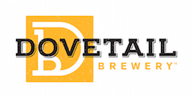

Media Contact:
Kurman Communications, Inc.
Cindy Kurman or Lee Barrie
(312) 651-9000
kurmanstaff@kurman.com

FOR IMMEDIATE RELEASE

Dovetail Brewery June News and Events

A Contemporary Art Show, June 24
Conception is coming to Chicago for the first time and setting up shop at Dovetail Brewery from 5 to 10 p.m. Saturday, June 24. Satisfy your aesthetic appetite with 30 of Chicago's best emerging visual artists and indulge your taste buds with food by DönerMen food truck and delicious craft food from Dovetail.

Purchase tickets here: https://conceptionarts.com/show/32623667267/Chicago.

Conception is a global movement striving to make a difference for each artist who participates and for the community at large. Their mission is to reshape and reenergize artistic communities around the world by inspiring ideas and providing a greenhouse for creativity. The organization’s award winning art events and festivals take place throughout the U.S and Europe and have been featured in The Wall St. Journal, Paper Magazine and ABC News. In addition to showing off fantastic works of art, these exhibits allow collectors a unique opportunity to purchase and network directly with the artists.

Ravenswood On Tap, June 24 and June 25
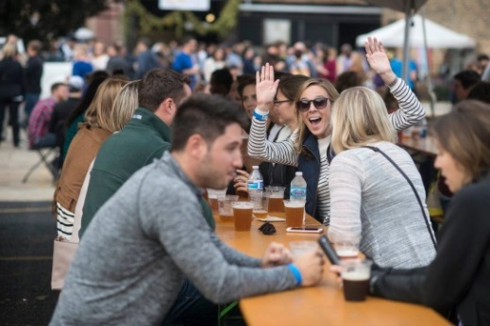
Ravenswood’s “Malt Row” is home to one of the country’s most prolific craft brewing communities and to celebrate, the area’s breweries are hosting the second annual Ravenswood On Tap craft beer festival. The two-day outdoor event will feature beer and spirits from local breweries, grub from some of Chicago’s favorite restaurants and food trucks, a lineup of original live music and handmade goods from local retailers and artists, making it the perfect place to enjoy the weekend. Bring a friend or the whole crew and join Dovetail and other fantastic craft breweries including Andersonville Brewing, Band of Bohemia, Begyle Brewing Co., Empirical Brewery, Greenstar Brewing, Half Acre Beer Company, KOVAL Distillery and Spiteful Brewing. The event takes place Saturday, June 24th from 1-9 p.m. and Sunday, June 25th from 1-6 p.m. at Ravenswood and Berteau. For more information, or to volunteer to work the event, visit http://ravenswoodchicago.org/ontap/.

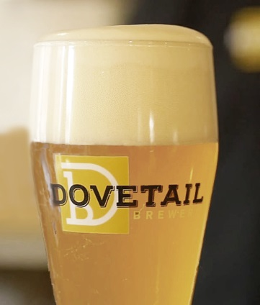
April Showers Bring May Flowers but June Brings Back Favorite Beer
June marks the return of Dovetail’s brews: the Grodziskie (just for the summer) and Vienna Lager.

Named after the town in Poland where it was first brewed, the Grodziskie is a 100% smoked wheat beer with light, citrus-like overtones and a surprising hint of spice and smoke in the back notes. Pale straw in color, with a feisty effervescence, it is more carbonated than Dovetail’s Hefeweizen and lower in alcohol (3.8%). Grodziskie is served with a lush head of foam that laces the glass beautifully with every sip; this beer is the perfect refreshment during a hot summer day.

The Vienna Lager is copper in color with a warm, malty character. Brewed with 100% Vienna malt and Styrian Golding hops, this lager has a higher alcohol content, at 5.1%, than the Grodziskie.

Heads Up Dovetail Lovers
The good times keep rolling. Dovetail has a ton of fun events coming up and will be at some of Chicago’s most popular events. Keep your eyes and ears open for more information.

July 7-July 9—Square Roots Fest (Lincoln Square)
July 21—Ravinia Event (Ravinia)
July 29—S. Loop Beer & Cider Fest (S. Loop)
August 19—Oak Park Micro Brew Fest (S. Loop)
August 25—Friday Night Flights (North Center)
September 23-September 24—Oktoberfestiversary (Dovetail Brewery)
September 30—Beer in the Woods (LaBagh Woods)
September 30—Riverside Beer Fest (Riverside)

About Dovetail Brewery
Dovetail Brewery, located at 1800 W. Belle Plaine in Chicago, Illinois, is a craft brewery owned by brewers Hagen Dost and Bill Wesselink, specializing in delicious, balanced beers brewed using traditional German and Belgian brewing methods. Signature beers include unfiltered German-style lagers, traditional Hefeweizen, Rauchbier and Lambic-style sour beers. Dovetail Brewery also produces a variety of special seasonal beers.

Taproom hours are Tuesday, 2 pm-10 pm; Wednesday, 2 pm-10 pm; Thursday, 2 pm-10 pm; Friday, 12 pm-11 pm; Saturday, 11 am-11 pm; Sunday, 12 pm-8 pm.

Tours are available every Saturday, 11 a.m. and 1 p.m. $15 per person. Space is limited. No reservations. Come early (doors open at 10:30 a.m.)!

The 22,000-square foot brewing facility includes an attractive tap room that is open to the public for drinking and retail sales. The tap room is also available as a rental space for private events.

Dovetail Brewery delivers beer by the keg to venues near the brewery and also to some select venues closer to the Loop. All bars, taverns and restaurants in the greater Chicagoland area that wish to serve Dovetail beer on tap are welcome to pick up kegs, in two sizes, at the brewery during normal business hours.

See what passionate beer lovers and industry professionals are saying about Dovetail: https://www.newsline360.com/dovetailbrewery/itn/.

For more information about Dovetail Brewery, please visit the brewery’s website at http://dovetailbrewery.com, their newsroom at http://www.newsline360.com/dovetailbrewery or contact Bill Wesselink or Hagen Dost by email. For information about special events, promotions and private events, contact Adrianne Dost. For additional information, call 773-683-1414.

Follow Dovetail Brewery on Twitter (https://twitter.com/dovetailbrewchi; @DovetailBrewChi)
Follow Dovetail Brewery on Facebook (https://www.facebook.com/DovetailBrewery/)
Follow Dovetail Brewery on Instagram (https://www.instagram.com/dovetailbrewery/)

# # #

