Immediate Release Contact: Reese Williams, 212-865-2982
April 2, 2024

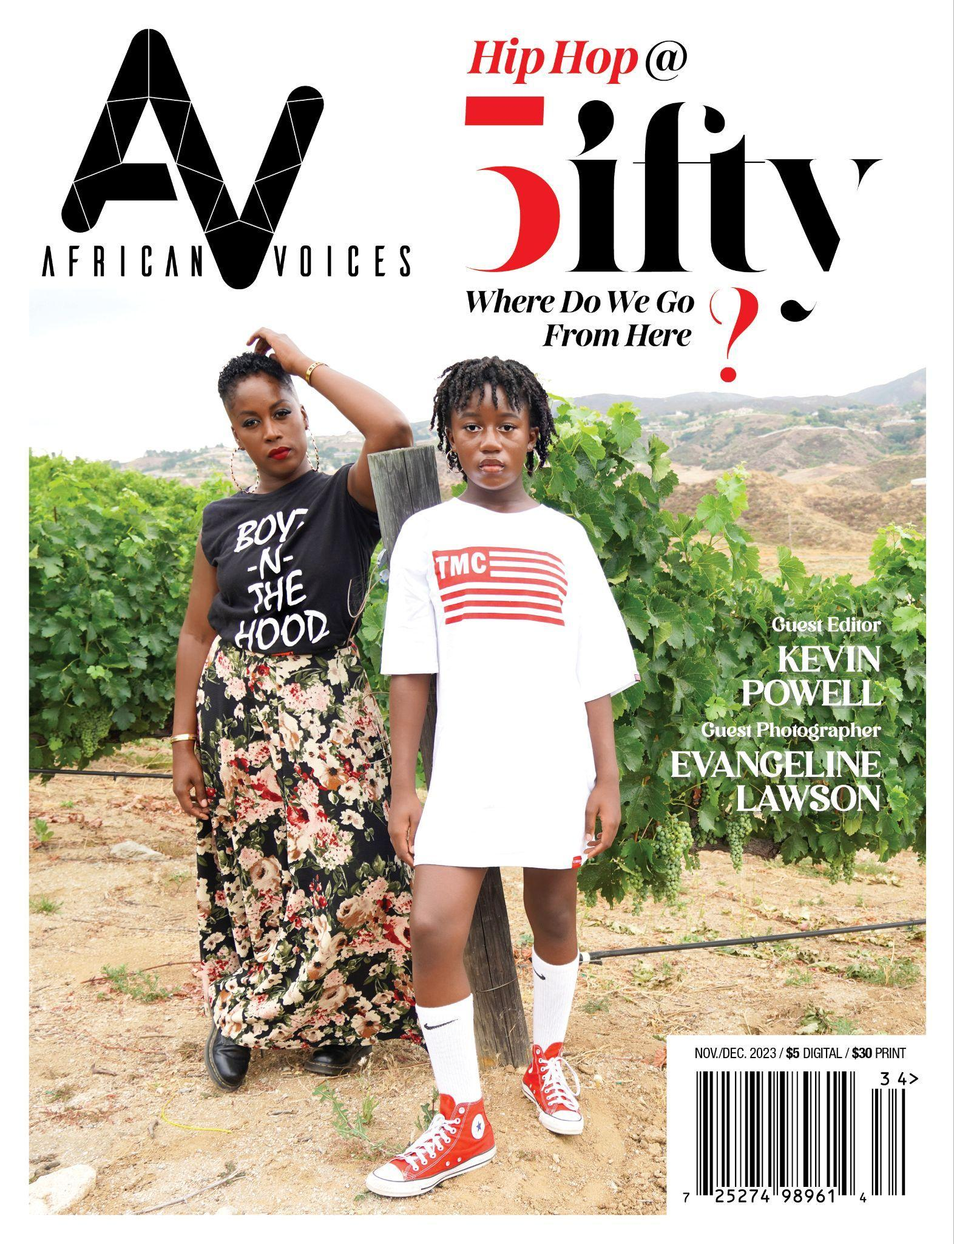

Reel Sisters presents a two-day event in celebration of African Voices’ special Hip Hop @50 issue guest edited by Kevin Powell and in honor of National Poetry Month.

SPECIAL SCREENING OF BLACK LOVE MANIFESTO!

Brooklyn, NY — Reel Sisters is proud to announce a two-day event featuring poetry selections by contributors of a collector’s item issue celebrating the recent 50th Anniversary of hip hop and a special screening of Ladies First: A Story of Women In Hip Hop (Ep. 4, Netflix) and Black Love Manifesto directed by Liza Jessie Peterson.

On April 12th, join us at the Riverside Theatre, 91 Claremont Ave, NY, NY, 10027, for an evening of readings and an episode screening of Ladies First: A Story of Women in Hip Hop, a Netflix docuseries celebrating the influential women of hip hop music and culture. CR Capers, founder of Harlem Film House & the Hip Hop Film Festival, will lead a panel with esteemed guests Crystal Whaley, co-executive producer of Episode 4 of Ladies First; DJ Franchella; Liza Jessie Peterson, director of Black Love Manifesto; and Evangeline Lawson, photographer and African Voices front cover artist. Guests are asked to view episode 4 of Ladies First on Netflix.

Derick Cross, African Voices Art Director and renowned beatbox performer, will MC the event, which will feature special performances by poets reg e gaines and Avery Danae Williams.

The celebration continues on April 13th with African Voices Hip Hop @ 50 Community Day at The Venue, 2284 Adam Clayton Powell Jr. Blvd, NY, NY 10030. From 3 pm to 8 pm, bring the entire family out for poetry readings, a creative writing workshop, and more as we commemorate the 50th anniversary of hip hop.

Both events are free, with a suggested donation of $7. For more information visit www.africanvoices.com and www.reelsisters.org. To RSVP call 212-865-2982.

Don't miss this historic celebration of hip hop culture and the voices that shape it!

Supporter acknowledgment:
African Voices is supported, in part, by Council members Farah Louis (35 C.D.) and Crystal Hudson (45 C.D.), the National Endowment for the Arts, New York State Council on the Arts, West Harlem Development Corp., Amazon Partnerships-CLMP and private donors.

About African Voices:
Founded in 1992, African Voices is a nonprofit arts organization devoted to showcasing art, literature, and films by artists of color. African Voices publishes a literary magazine and presents literary readings, art exhibitions, and artistic workshops throughout NYC. The organization sponsors Reel Sisters of the Diaspora Film Festival & Lecture Series, the first Oscar-qualifying film festival in the nation devoted to women of color (www.reelsisters.org). Spelman College is archiving African Voices magazine for future generations to access.

African Voices’ historic Hip Hop issue guest edited by Kevin Powell, the author of 16 books, features 63 writers spanning four generations. Limited print copies can be purchased online at AV Hip Hop @50.

For additional information:
Reese Williams, programmingcoordinator@africanvoices.nyc

Guest Artist Bios

CR Capers is the Founder and CEO of Harlem Film House, a 501(c) (3) corporation that turns artists into creative entrepreneurs. As Executive Director, CR creates and produces film & music festivals and operates year-round workshops, theatre productions and live events, while also offering business consulting to filmmakers and content creators in underserved communities around the world.
Derick Cross (D. Cross) is a Queens, NY born Brooklyn-based multi dimensional visual and vocal hip hop artist D-Cross has performed at venues nationally and internationally, including Madison Square Garden and Lincoln Center. This “Vocal Beat Expressionist .”
DJ Franchella: After moving to New York City, a decade ago, the California native, educator, and event curator, among other things, Frances Harris is better known around New York City as DJ Franchella. Curator of some of NYC's most creative and highly anticipated events, DJ Franchella's passion for promoting art & culture ranks just as high as her passion for rocking a party. After moving to Bedstuy just days after graduating from UCLA, Franchella expanded her musical knowledge to the sounds of Brooklyn & uptown. Within months after moving to New York as part of a teaching fellowship, Franchella became a DJ. A native of the west coast, caught between two generations, Franchella' music diversity allows her to play for any crowd. From spinning at some of New York's clubs like The Anthony to hot spots in Europe, Puerto Rico & Bermuda to DJing her curated events, Franchella is known to keep the party going and the vibes right no matter the occasion. Franchella's claim to fame includes DJing twice for the Beyhive VIP pre-party during Beyonce's Formation Tour, both stops in New York City.
reg e gaines is a poet, playwright, director, lecturer and artistic director of the Downtown Urban Arts Festival since 2007. He is author of four books of poetry and is currently writing and producing The 88, with music by Calvin Gaines.
Evangeline Lawson is a multi-talented photographer, writer, and filmmaker committed to creating and telling culture-preserving stories. She is the guest photographer for African Voices’ massive exploration, in print and digital, of hip-hop culture, “Hip-hop at 50: Where Do
We Go From Here?” Evangeline’s photography also appears on the cover of Arts Today, on both the poetry book and spoken word poetry album covers of Kevin Powell’s Grocery Shopping With My Mother, and throughout the documentary film When We Free The World, a meditation on Black manhood and Black fatherhood in America, of which Evangeline is also co-producer and co-writer. Her writings have appeared in The Washington Post and The Guardian, among other publications. A native of America’s West Coast, she currently lives between Southern California and Brooklyn, New York. You can see more of Evangeline’s photography, and her writings, too, at www.evangelinelawson.net

Liza Jessie Peterson is an artivist; an actress, playwright, poet, author and youth advocate who has worked steadfast with incarcerated populations for more than two decades. Her critically acclaimed one woman show, The Peculiar Patriot, was nominated for a Drama Desk Award, Elliot Norton and a recipient of a Lilly Award. The play is also available on Audible. Liza performed The Peculiar Patriot in 35 prisons across the country and a documentary, Angola Do You Hear Us; Voices from a Plantation Prison, features her historic performance of The Peculiar Patriot at Louisiana State Penitentiary (aka Angola) which is streaming on Paramount Plus and Amazon Prime, and was shortlist for an Academy Award.

Liza is the lead writer on a television series in development with Felicity Huffman and John Wells Production.

Her memoir, ALL DAY; A Year of Love and Survival Teaching Incarcerated Kids at Rikers Island (Hachette publishing) was commissioned by The Old Globe Theater to adapt the book into a stage play, and she has developed a TV pilot based on the book. Liza was featured in Ava DuVernay’s Emmy award winning documentary, The 13th, and was a consultant on Bill Moyers documentary Rikers (PBS).

Crystal Whaley is a double EMMY Award winning creative producer and development executive in film/TV/digital offering a unique combination of cross-functional skills with over 20 years of experience with a specialized expertise in content development and acquisition and creative direction. Crystal is responsible for the overall financial sustainability and creative integrity of multiple shows/projects, including the oversight of all logistics necessary to meet creative mandates, broadcast standards and brand recognition. She’s developed, produced and supervised award winning series TV, commercials, music videos and nationally syndicated and Peabody nominated documentaries for TLC, PBS and Showtime.
Avery Danae Williams is a multi-published writer, activist, and singer from North Brunswick, New Jersey, but currently living in Jersey City, New Jersey. She is a sophomore at Princeton University, who plans to major in Cultural Anthropology with a minor in Creative Writing next Spring. You can read more of her work on instagram.com/unpackingmyworld, unpackingmyworld.substack.com, and unpackingmyworld.medium.com.
# #. #

