FOR IMMEDIATE RELEASE
Contact:
Holly Jo Anderson
+1 952-738-8177, ext. 700
holly@veritasmarketing.com

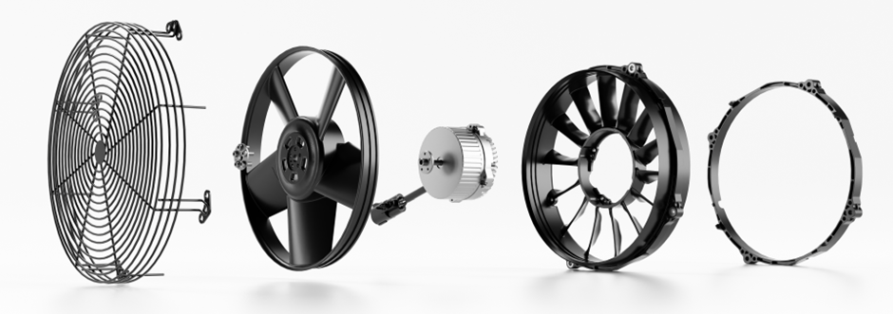Multi-Wing Transforms Off-Highway Electrification with Customizable DC Electric Fans

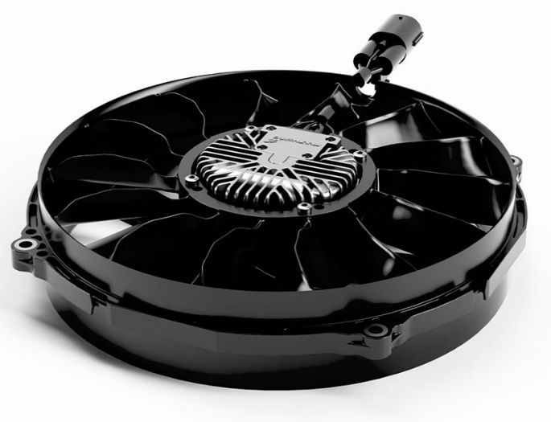
Vedbæk, Denmark — June 3, 2024 — Multi-Wing, a forerunner in fan technology, is stepping up to support off-highway original equipment manufacturers (OEMs) on their electrification journey. With a commitment to sustainability and innovation, Multi-Wing introduces the DCmax312 electric fan, meticulously crafted to meet the unique demands of modern internal combustion engines (ICEs), electric batteries and fuel cell machinery.
Why Settle for Standard Fans?
“OEMs no longer need to compromise on design, cooling efficiency or performance by purchasing off-the-shelf fans,” explains Andreas Hennicke, global business development manager at Multi-Wing. “We’ve seen OEMs struggle with generic solutions, designing systems around standard components. It’s no longer necessary to settle for stock products when superior is within reach. No more trade-offs, just cutting-edge solutions.”
Collaborating closely with customers, Multi-Wing tailors electric fans to precise specifications, resulting in enhanced airflow, efficiency and performance that align with industry sustainability goals.
The Multi-Wing Advantage
- Aerodynamic Mastery: Multi-Wing’s engineers bring their aerodynamic expertise to the table. These electric fans aren’t just functional; they’re sleek, efficient and designed for excellence.
- Modularity Unleashed: DCmax312 electric fans adapt seamlessly to various applications. Whether it’s an ICE, battery electric vehicle or fuel cell equipment, Multi-Wing has it covered.
- Real-World Performance: Eliminating guesswork, Multi-Wing’s responsive staff leverages superior engineering tools to provide real-world performance data for proven results.
- Battle-Tested Reliability: Multi-Wing’s products thrive in the harshest environments. State-of-the-art equipment and in-house aerodynamic validation facilities ensure peak performance, even in extreme environments.
Versatility Meets Precision
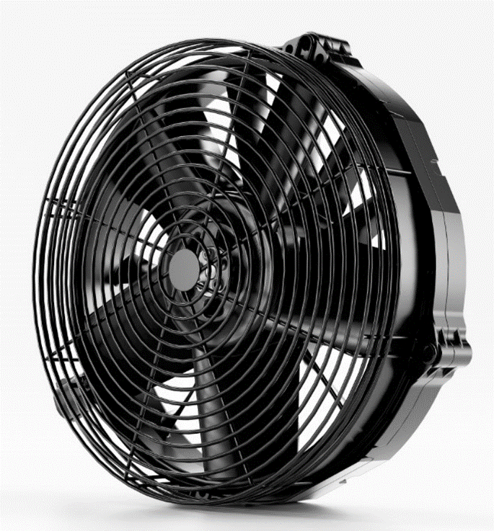
DCmax312 electric fans are installed in a range of off-highway equipment using ICEs, which require strong, durable products. Multi-Wing’s new electric fans are an ideal solution for diverse earthmoving equipment, such as excavators, wheel loaders, and dump trucks, as well as material handling equipment, including telescopic handlers, reach stackers and rough terrain trucks.
For battery electric and fuel cell applications, DCmax312 fans ensure optimal performance and longevity of other involved components.

Accelerate Your Journey
Multi-Wing doesn’t just sell fans. The company propels progress, reduces time to market, elevates designs, and embraces the future. It provides electrification with confidence and optimal engine temperature control.
For further information, visit www.multi-wing.com and reach out to a sales application engineer at info@multi-wing.com.

Multi-Wing
Multi-Wing’s mission is to shape airflow for future generations through energy saving and tailored airflow solutions. Offering a global footprint with local presence, the company combines aerodynamic expertise and leading research and development. Multi-Wing serves applications in various segments such as engine cooling and heating, ventilation, air conditioning and refrigeration.

###

